The Sun Bowl
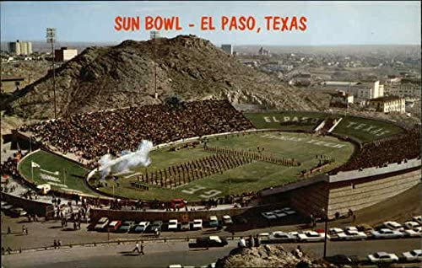
The Sun Bowl is located on the UT-El Paso campus
The Sun Bowl is a college football bowl game played in El Paso, Texas. Currently the teams are selected from the Pac-12 Conference and the Atlantic Coast Conference. The bowl game has been played since 1935 and today takes place during the last week of December. It is the second-oldest bowl game played after the Rose Bowl.

November 22 1935 The China Clipper (plane) leaves California to deliver mail across the Pacific
January 1st 1935 1st Sun Bowl Game played
February 17 1936 The Phantom comic first appears in newspapers

The Sun Bowl is tied with the Sugar and Orange bowls as the second-oldest bowl games (the Rose Bowl, started in 1916, is the first). The first three Sun Bowl games were held at El Paso High School Stadium, then the bowl moved to Kidd Field before the current Sun Bowl Stadium was ready in 1963. The Sun Bowl is one of only two bowl games not aired on the ESPN family of networks. It has been aired on CBS each year since 1968. It is also one of only two games CBS airs that does not involve an SEC team (the Army-Navy game is the other).
From https://www.ncaa.com/news/football/article/2013-12-17/history-sun-bowl
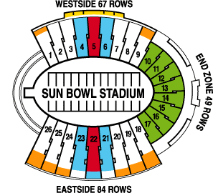

The Kellogg Company sponsors the game The Sun Bowl seats about 52,000

Scoring Rubric
Same font throughout (5 points)
No underlines or different-colored type (unless it’s used as a part of a hyperlink or caption) or numbers [3] indicating citations (5 points)
All information on one page (5 points)
No obvious misspellings or capitalization errors (5 points)
Short description in your own words: who, what, where is it, when did it happen, why is it significant (5 points each/25 total)
The Who, What, Where, When and Why should be bold-faced in black in your paragraph.

Title is at the top and it is the largest font (5 points)
1st picture is under title and centered and has a caption beneath it (10 points)

You list two events in US History that happened within three months before and after your topic (20 points)

Cited paragraph (5 pts. for text/ 5 for correct and hyperlinked citation)-no wikipedia

2 pictures related to your topic with captions describing what is being shown (5 points each)

